**Computer Network Lab – Week 2**

**PES1UG20CS806**

**Divyanshu Sharma**

1. **Configuration of Apache Server and Client Environment**

* To create a server – client architecture, two Virtual Machines were setup. The former is referred to as the server machine and the latter is the client machine.
* Apache Server was installed and configured on the server machine, and a static webpage consisting of 10 objects (images) was created and hosted on the local network between these machines.
* We need to observe and determine the effect of the number of persistent connections on the load time of this static webpage.
  1. **Setting up Apache Server**
* The Apache Server can be installed with sudo apt install apache2.
* The status of the newly installed server can be viewed **using systemctl status apache2.**

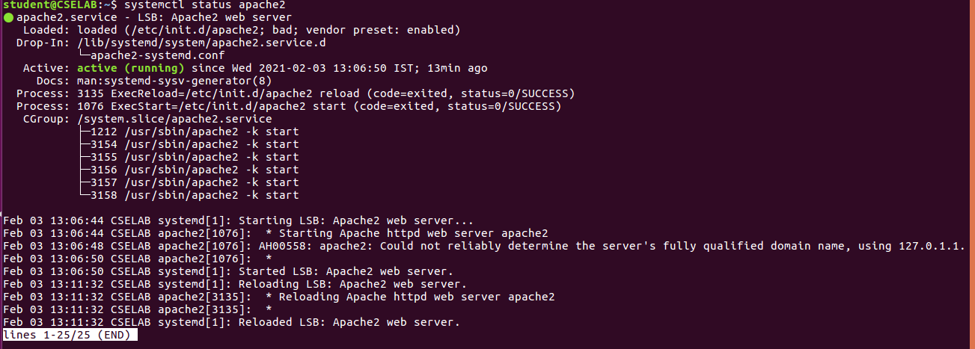

* The Apache Server also needs to be configured to allow persistent connections. This is done by editing the **apache2.conf** configuration file and setting the options

o **Keep Alive to On**

o **MaxKeepAliveRequests to 2**

**Command:** $sudo nano /etc/apache2/apache2.conf

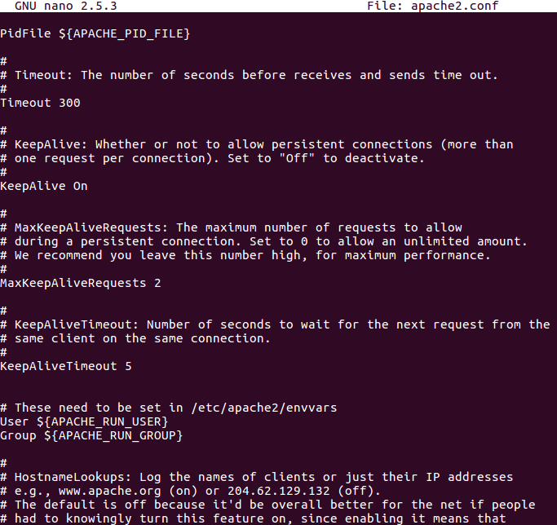

* 1. **Adding Custom IP Addresses for Server and Client**
* A custom IP Address was set for both the Server and Client machines
* The **Server IP Address** was set to **10.0.8.06/24** and the **Client IP Address** was set to **10.0.8.80/24**
* The IP address were assigned using the **sudo ip addr add** command

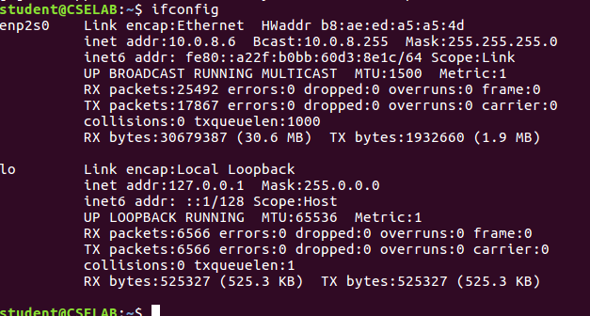

* 1. **Hosting the Webpage**
* The webpage can be hosted by moving the html script and the images to the server path
* The server path is **/var/www/html/**

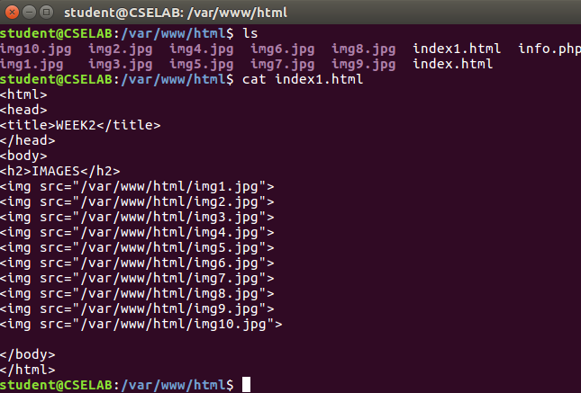

**Created index1.html file in the path /var/www/html/**

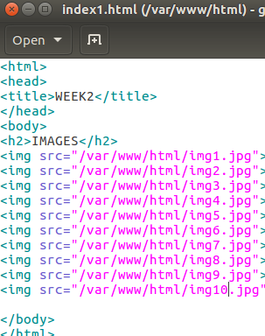

1. **Non-Persistent Connection**

* To setup a non-persistent connection, we need to configure a few settings on our browser
* On Firefox, we set the **max-persistent-connections-per-server to 0** and **persistent-settings to false**

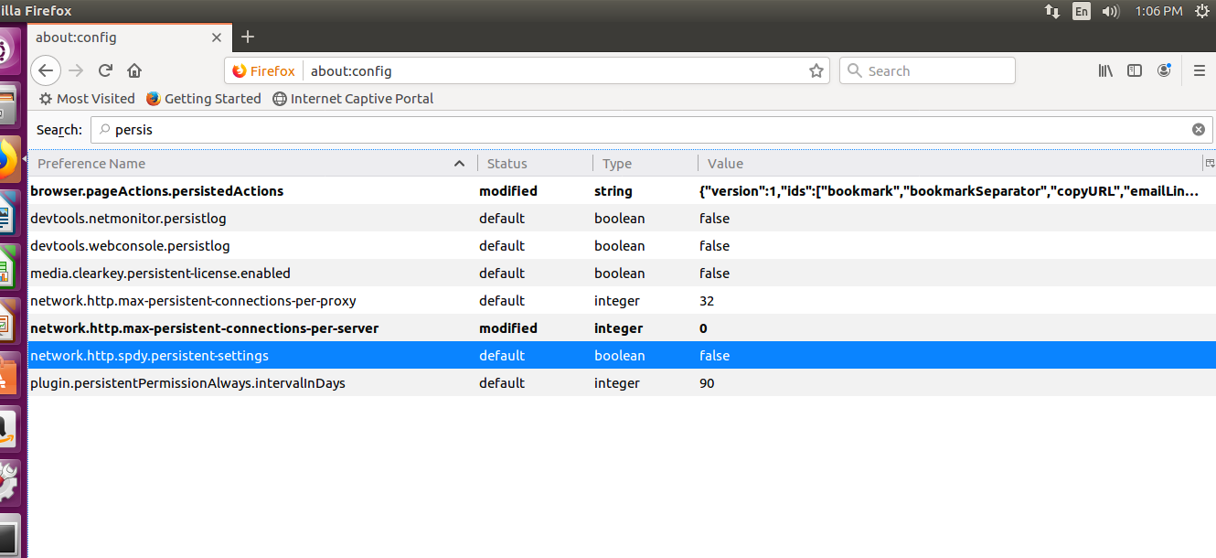

* Access web page on client-side browser (Firefox)
* The client could access the file as: **10.0.8.6/index1.html**
* Here the file name is index1.html present in server. So, by tying **10.0.8.6/index1.html** in client browser, we will be able to open the requested web page

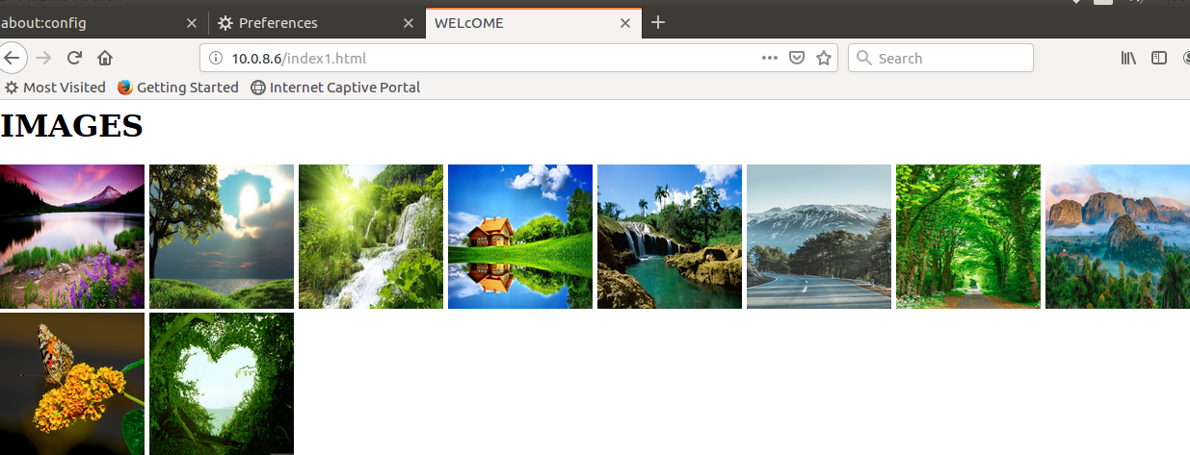

* 1. **Non-Persistent connection Packet Capture Screenshot**

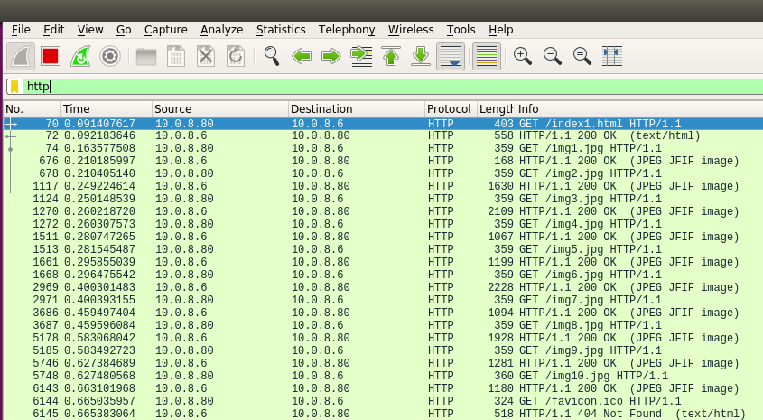

0.663101968 - 0.091407617 = 0.571694351

1. **Persistent Connection**

* To setup a persistent connection, we need to configure a few settings on our browser
* On Firefox, we set the max-persistent-connections-per-server to anything greater than 0 and persistent-settings to **true**

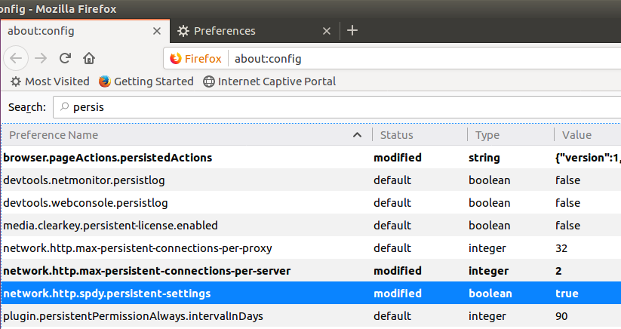

**3.1. 2 Persistent Connections Packet Capture Screenshot**

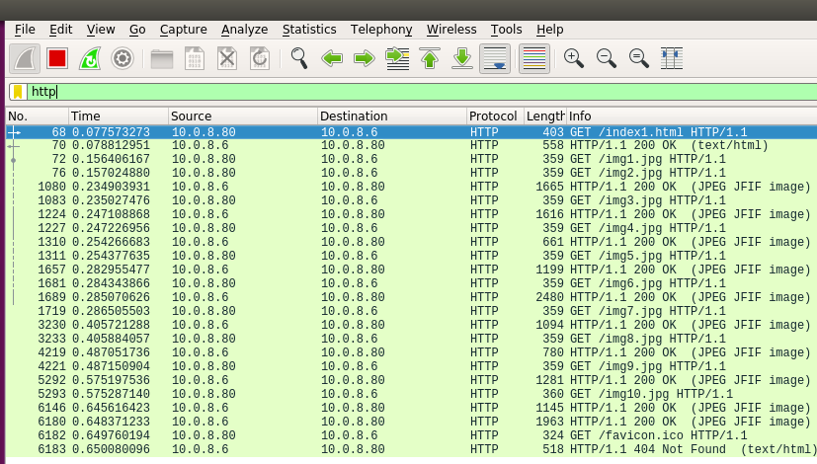

0.648371233 - 0.077573273 = 0.57079796‬

**3.2. 4 Persistent Connections Packet Capture Screenshot**

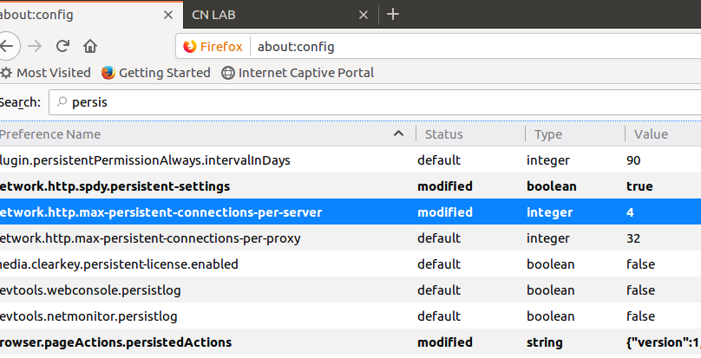

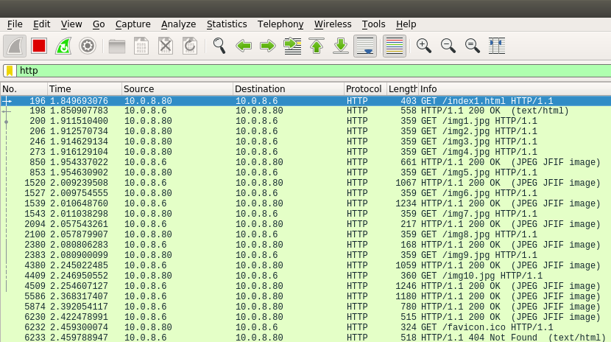

2.422478991 - 1.849693076 = 0.572785915

**3.4.** **6 Persistent Connections Packet Capture Screenshot**

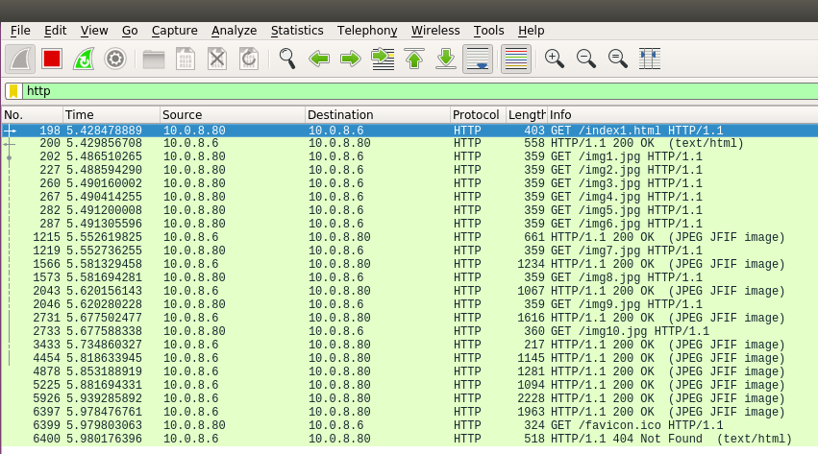

5.978476761 - 5.428478889 = 0.549997872‬

**3.5. 10 Persistent Connections Packet Capture Screenshot**

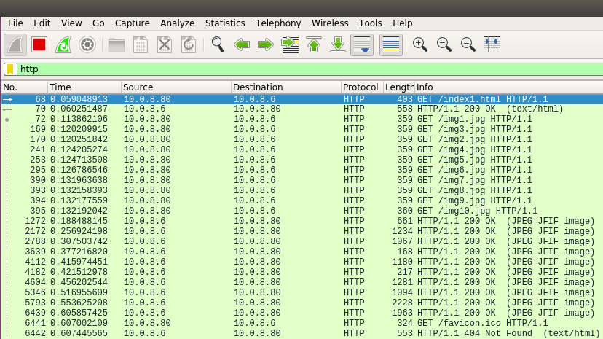

0.605857425 - 0.059048913 = 0.546808512

1. **Observations:**

* We can calculate the total load time as the difference between the first GET time which corresponds to the time when the html page was requested and the last response time, which corresponds to when the last image was sent back.
* On doing so, we can construct the following observations table –

|  |  |  |  |
| --- | --- | --- | --- |
| **Persistent Connections** | **Time at first GET** | **Time at last Response** | **Load Time** |
| 0 | 0.091407617 | 0.663101968 | 0.571694351 |
| 2 | 0.077573273 | 0.648371233 | 0.57079796‬ |
| 4 | 1.849693076 | 2.422478991 | 0.572785915 |
| 6 | 5.428478889 | 5.978476761 | 0.549997872‬ |
| 10 | 0.059048913 | 0.605857425 | 0.546808512 |